CEC'2025 Competition on Dynamic Scheduling of Flexible Flow Shop with Random Job Arrivals

The scheduling problem of flexible flow shop with random job arrivals(FFSROA) is a sophisticated dynamic optimization problem. Firstly, the search for a feasible and optimal schedule solution space is complicated by the coupling of two discrete subproblems, job selection and machine allocation, which are inseparable and intertwined. Secondly, the local optimal can be achieved due to the existence of a large number of scheduling schemes, that is multimodal. The non-convexity of the problem leads to no clear optimization gradient, then makes the optimization process more complex. Finally, since jobs arrive randomly, the scheduling needs to be dynamically optimized in real time. The algorithm is required to be able to re-evaluate and re-optimize operations without interruption, which poses a higher challenge to the time efficiency. In addition, in practical scheduling scenarios, the number of random arriving orders often reaches thousands, so the large-scale property exacerbates the complexity of the dynamic scheduling problem of FFSROA. Therefore, it is crucial to consider both time efficiency and search efficiency to solving these problems, which will bridge the gap between complex real-world optimization challenges and advanced optimization algorithms.

The dynamic scheduling problem of FFSROA poses a challenging optimization issue that is widely encountered in practical scenarios, where evolutionary algorithms have significant potentials to solve the scheduling problem of FFSROA. This is the first competition of SFFSROA at CEC conferences in recent years, which will advance the application of evolutionary computation methods to real-world problems.

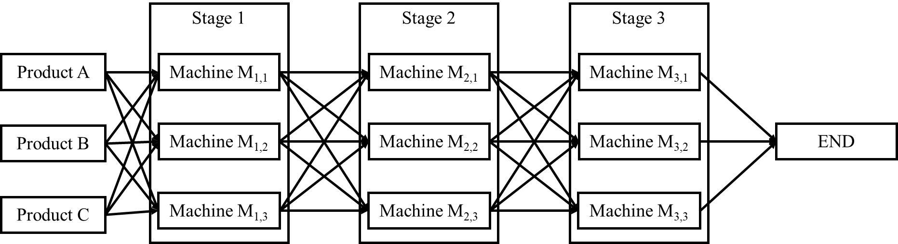

Figure 1 The flexible flow shop scenario.

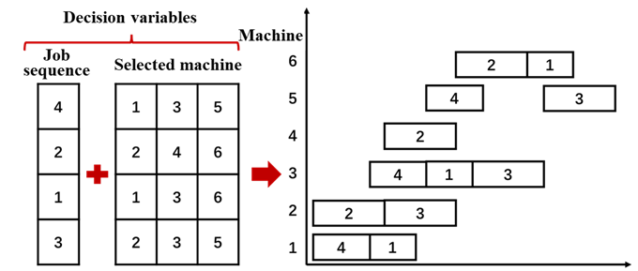

Figure 2 The diagram of decision variables.

In this competition, we have carefully selected three representative flexible flow shop scenarios. As shown in Figure 1, each scenario is constructed by different products, processing stages, and multiple parallel machines in each processing stage. Typically, the decision variables include the processing sequence of jobs and the selection of parallel machines at each stage, with the on-time delivery rate of jobs as the objective, as shown in Figure 2. Overdue orders will be stopped for processing. The competition will present three scales of dynamic scheduling problems of flexible flow shop with random job arrivals: 1000 orders, 5000 orders, and 10000 orders (detailed specifications will be provided on the competition website). As an extension of the dynamic scheduling problem of flexible flow shop, this competition aims to propel research in production scheduling and advance optimization algorithms, exploring potential research directions in dynamic optimization.

Participants need to develop an algorithm that can efficiently solve this complex scheduling problem. Participants are required to submit their complete source code. Additionally, a code documentation briefly introducing the structure, functions, and variables of the code should be provided to facilitate rapid understanding by the organizers. The evaluation will be conducted under identical computing resources, encompassing computing power and time, across all problem instances in three flexible flow shop scenarios. The optimal scheduling solutions output by participants' algorithms before the computation time expires will be compared. The participant who achieves the highest number of optimal solutions across all instances will be crowned the champion. In cases of equal performance, further criteria such as the number of suboptimal solutions and the average computation time will be considered. **Participants should submit their source code, and documentation via the designated email (shichangwei@sia.cn)** and are allowed to make multiple submissions before the deadline. The organizers will begin evaluating the submissions after the deadline and will announce the results once the evaluation is complete. Participants can seek support and feedback through the provided contact information. We estimate that there will be about 20 participants in this competition

**Sponsor:**

An award funding of USD 500 will be applied from the IEEE CIS Education Competition Subcommittee.

**Organizers:**

Name: Chang Liu

Affiliation: Shenyang Institute of Automation, Chinese Academy of Sciences, Shenyang, China

Email: changl@sia.cn

Short Bio: Chang Liu has long been engaged in theoretical and applied research on complex manufacturing process modeling, production scheduling, and intelligent optimization. She has undertaken multiple national level science and technology projects, including the 863 Program, National Major Science and Technology Projects, and Natural Science Foundation. Her group have accumulated rich theoretical and applied research experience in complex manufacturing system production scheduling and intelligent optimization, as well as closed-loop optimization of production scheduling based on data and knowledge dual drive, forming a comprehensive and in-depth method system. Assoc. Prof. Liu has published over 50 academic papers, over 20 patents and software copyrights, and won the first prize of provincial and ministerial level scientific and technological progress, invention patent award, and 5 scientific research achievements. The "Zhongke Yunyi Intelligent Scheduling System" developed under her leadership, which has been practically applied in discrete and semi-process industries.

Name: Rui Wang

Affiliation: Shenyang Institute of Automation, Chinese Academy of Sciences, Shenyang, China

Email: wangrui@sia.cn

Short Bio: Rui Wang received his M.Sc. degree from the School of Software, Northeastern University in 2020. Currently, he is an engineer at the Shenyang Institute of Automation, Chinese Academy of Sciences. His research areas include multi-objective evolutionary optimization, flow shop scheduling, and evolutionary deep reinforcement learning.

Name: Changwei Shi

Affiliation: Shenyang Institute of Automation, Chinese Academy of Sciences, Shenyang, China

Email: shichangwei@sia.cn

Short Bio: Changwei Shi received his M.Sc. degree from the College of Power and Energy Engineering, Harbin Engineering University, in 2023. He is currently an Assistant Engineer at the Shenyang Institute of Automation, Chinese Academy of Sciences. His research interests include job shop scheduling optimization and application of evolutionary algorithms.

Name: Name: Xinjie Zhang

Affiliation: Jiuzhang Intelligence Technology Co., LTD , Shanghai 200437, China

Email:xinjiezhang@189.cn

Short Bio: Xinjie Zhang graduated from Fudan University, with 20+ years IT service experience in IT industry: Including operation and optimization applications, project development, management and consulting experiences.

Name: Yaochu Jin

Affiliation: School of Engineering, Westlake University, Hangzhou 310030, China

Email: jinyaochu@westlake.edu.cn

Short Bio: Prof. Jin received the B.Sc., M.Sc., and Ph.D. degrees from Zhejiang University, Hangzhou, China, in 1988, 1991, and 1996, respectively, and the Dr.-Ing. degree from Ruhr University Bochum, Germany, in 2001. He is a Professor in School of Engineering, Westlake University, China. He is an Alexander von Humboldt Professor for Artificial Intelligence, Chair of Nature Inspired Computing and Engineering, Faculty of Technology, Bielefeld University, Germany. He is also a Distinguished Chair, Professor in Computational Intelligence, Department of Computer Science, University of Surrey, U.K. He was a ''Finland Distinguished Professor'' of University of Jyvaskyla, Finland, ''Changjiang Distinguished Visiting Professor'', Northeastern University, China, and ''Distinguished Visiting Scholar'', University of Technology Sydney, Australia. His main research interests include evolutionary optimization, evolutionary learning, trustworthy machine learning, and evolutionary developmental systems. Prof. Jin is presently the Editor-in-Chief of Complex & Intelligent Systems. He was the Editor-in-Chief of the IEEE TRANSACTIONS ON COGNITIVE AND DEVELOPMENTAL SYSTEMS in 2016-2021 and an IEEE Distinguished Lecturer in 2013--2015 and 2017--2019, the Vice President for Technical Activities of the IEEE Computational Intelligence Society (2015--2016). He is the recipient of the 2018 and 2021 IEEE Transactions on Evolutionary Computation Outstanding Paper Award, and the 2015, 2017, and 2020 IEEE Computational Intelligence Magazine Outstanding Paper Award. He was named by the Web of Science as “a Highly Cited Researcher” from 2019 to 2021 consecutively. He is a Member of Academia Europaea.